

**ETHICAL HACKING INTERNSHIP**

**NAME: SOUMIK SEAL**

**Task 1:**

In Session 22 we introduced you to portswigger labs.

Portswigger is a website which has so many vulnerable labs which helps you to learn about other vulnerabilities in real life.

You can visit Portswigger labs at https://portswigger.net/ so the exact task for you now is there are several XSS labs on this website <https://portswigger.net/web-security/all-labs>.

You can just choose any 5 of them and solve it.

We are leaving the choice up to you. Every lab on the website has a hint section which you can use to solve the labs if you are stuck somewhere.

Watch me solve one lab to give you a demo.

After solving you should see something like “Solved Status” on the top of the lab. That status is necessary to pass the task out.

If you need any more help solving labs, you can use Google to find out a solution video available on YouTube.

**TASK 1 SOLUTION**

1.

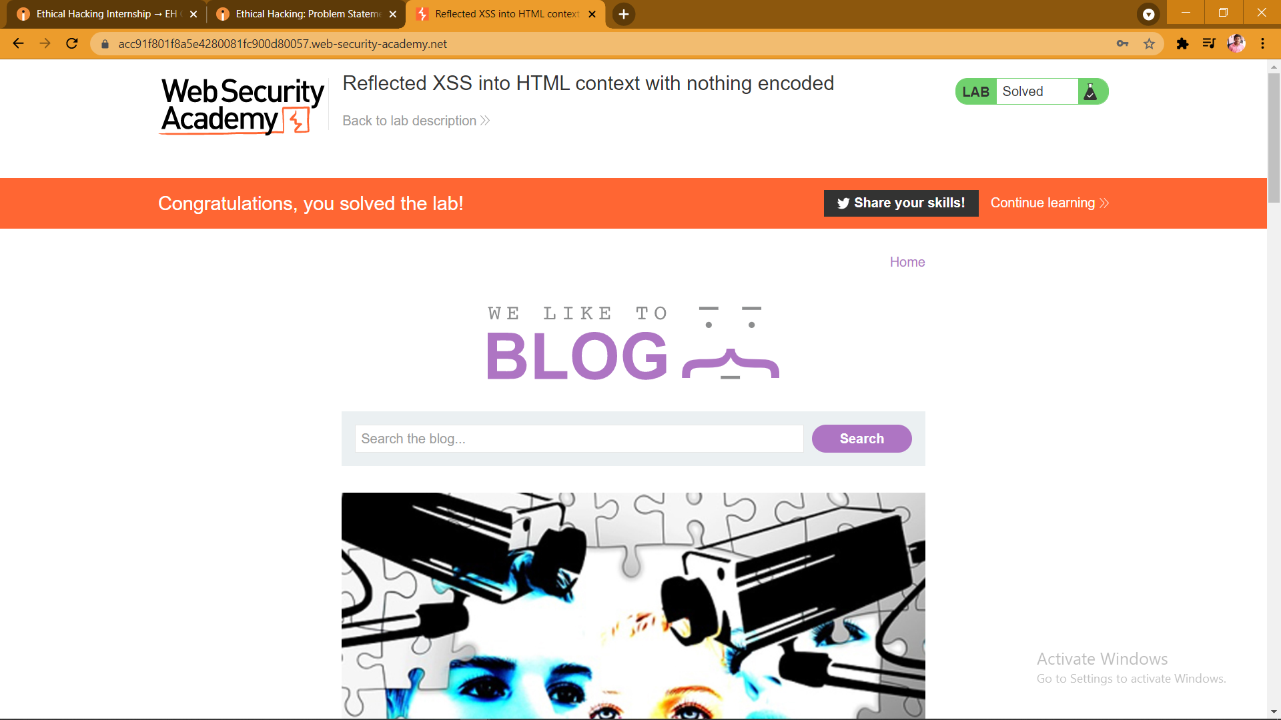

2.

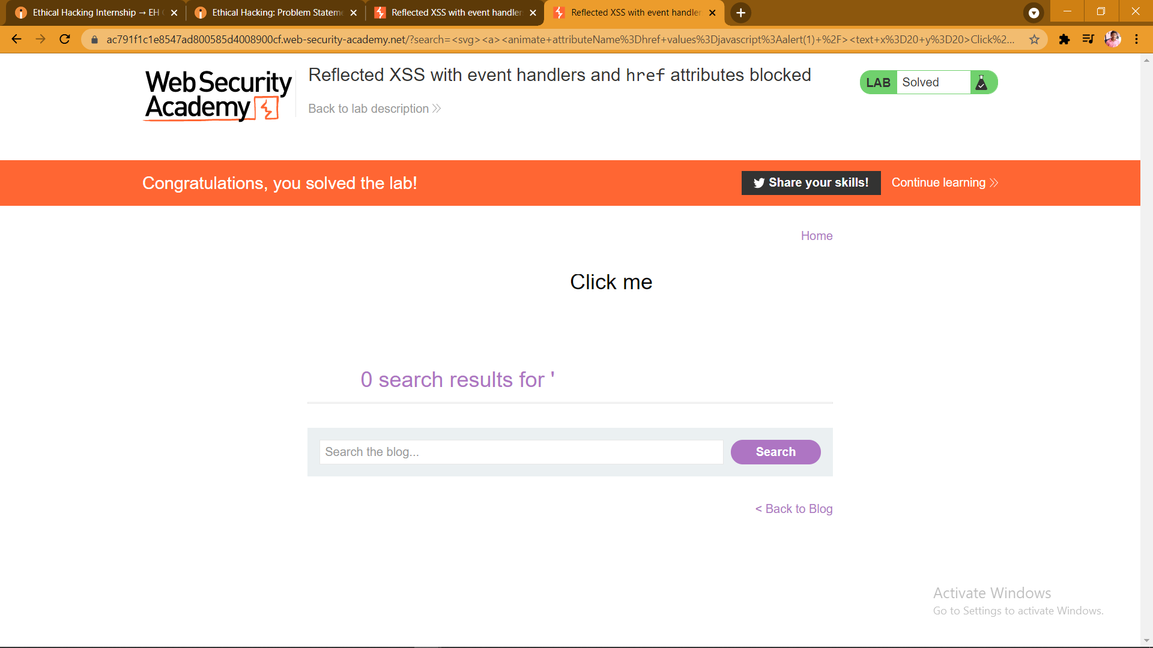

3.

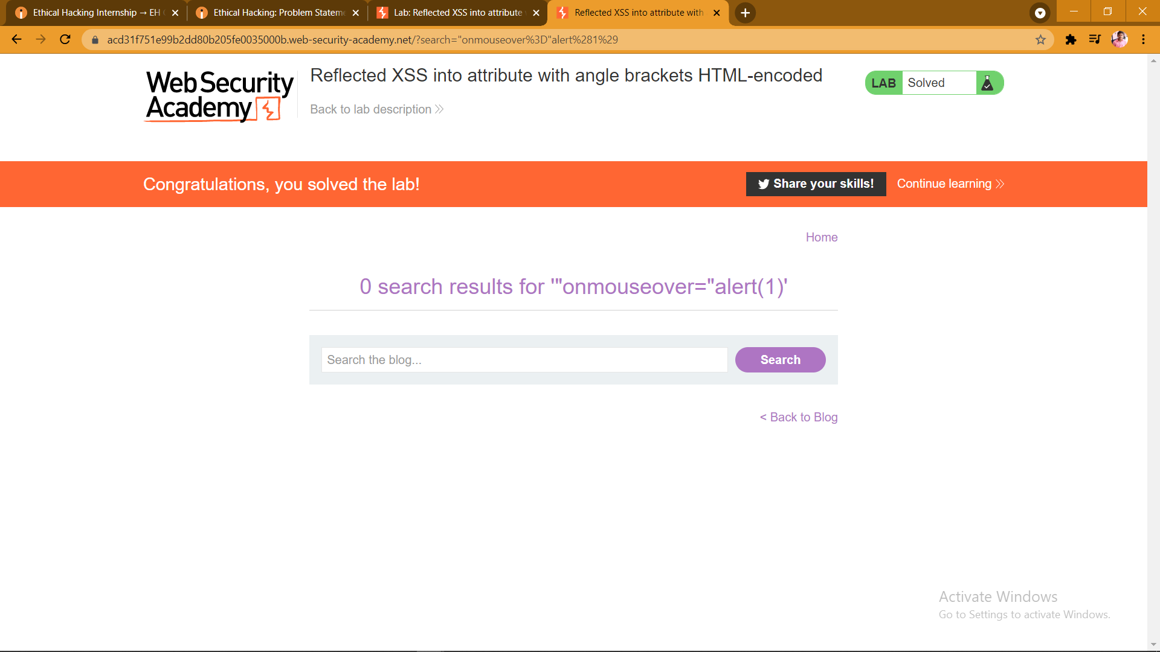

4.

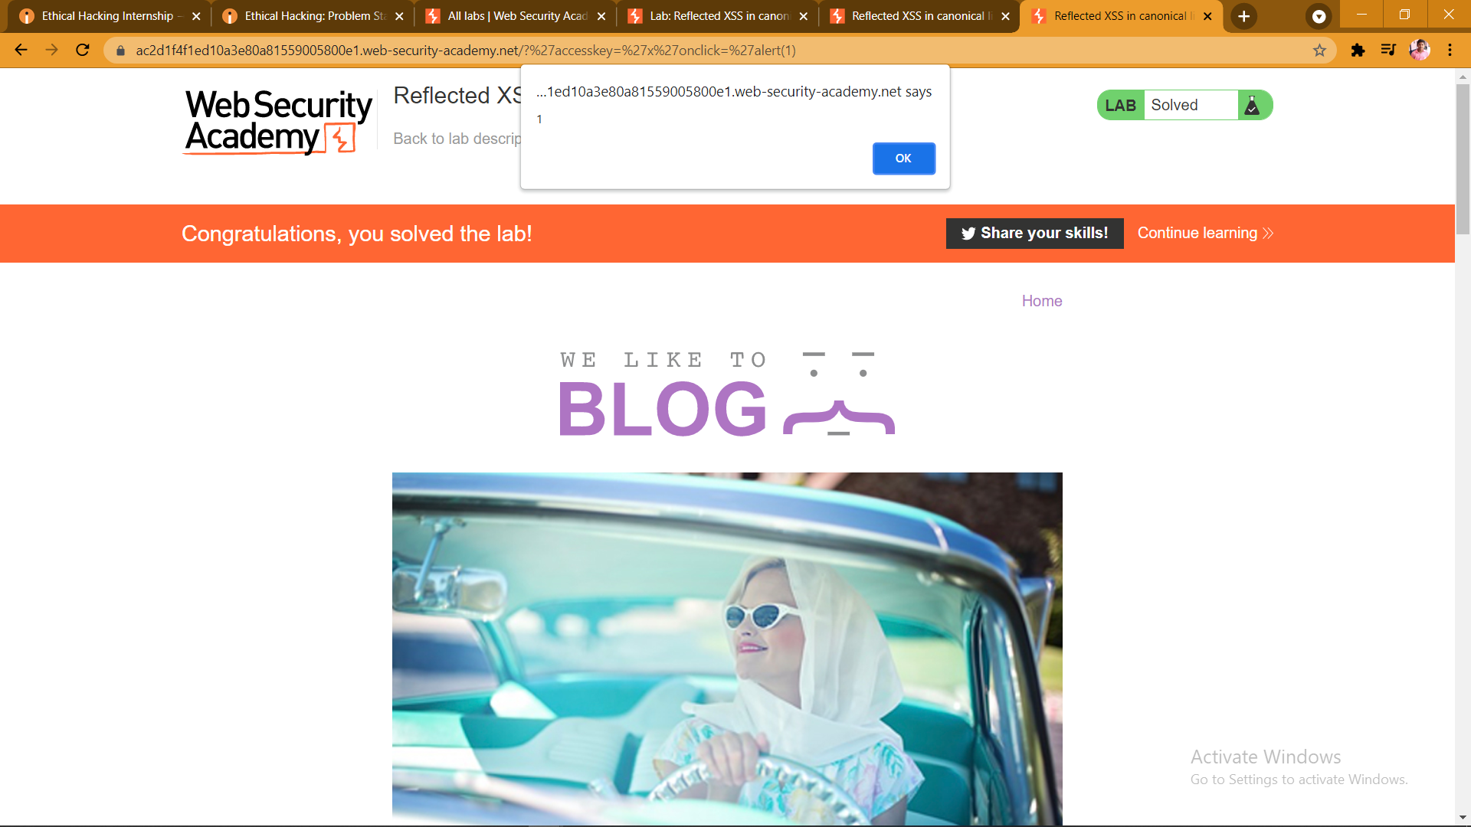

5.

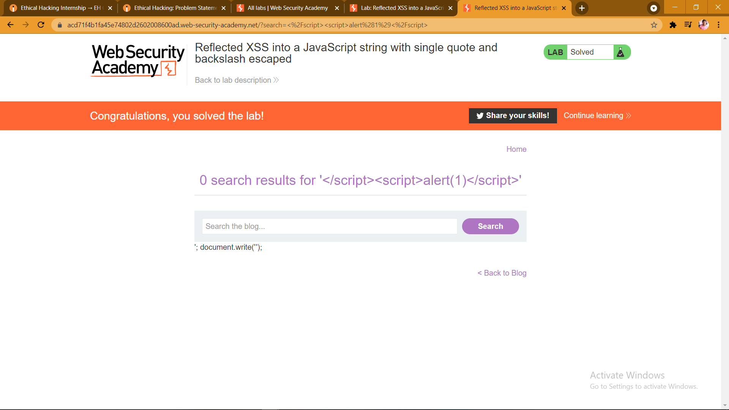

**SCREENSHOTS OF THE SOLVED LABS**

